**PREDICT HEART FAILURE USING IBM AUTO AI SERVICE**

**Team Members**

Sai Sharan

Rajitha Puli

Routhu Sahini

Akshay Reddy

Rohan Kumar Singh

**PREDICT HEART FAILURE USING IBM AUTO AI SERVICE**

**1.INTRODUCTION**

The heart is a vital organ in the human body that is liable for blood circulation. The heart is responsible for oxygen and energy supply to all organs of the body including itself. Heart failure causes the abnormal blood circulation in the body that might be fatal for human life. Hence, if the heart stops its normal functionality, the whole system will be dead. From the literature, various risk factors are identified that cause the heart disease. The risk factors of heart diseases are classified into two major types such as the risk factors that can alter, e.g., smoking and physical exercise, and the risk factors that cannot alter, e.g., gender, age, and patient’s family history .Heart failure, sometimes known as congestive heart failure, occurs when your heart muscle doesn't pump blood as well as it should. Certain conditions, such as narrowed arteries in your heart (coronary artery disease) or high blood pressure, gradually leave your heart too weak or stiff to fill and pump efficiently.

**1.1 OVERVIEW**

Not all conditions that lead to heart failure can be reversed, but treatments can improve the signs and symptoms of heart failure and help you live longer. Lifestyle changes — such as exercising, reducing sodium in your diet, managing stress and losing weight — can improve your quality of life.One way to prevent heart failure is to prevent and control conditions that cause heart failure, such as coronary artery disease, high blood pressure, diabetes or obesity.

**1.2 PURPOSE**

This project prevents the people from the avalanche by priory informing them if there is a chance of the occurrence of avalanche or not.In medicine, the diagnosis of diabetes is according to fasting blood glucose, glucose tolerance, and random blood glucose levels. The earlier diagnosis is obtained, the easier we can control it. Machine learning can help people make a preliminary judgment about heart failure according to their daily physical examination data, and it can serve as a reference for doctors.

**2.LITERATURE SURVEY**

**2.1 EXISTING PROBLEM**

Heart disease has been the leading cause of death for decades in the United States so it’s no surprise that heart failure rates, which is a specific type of heart disease characterized by when the heart is too weak to pump blood throughout the body, are on the rise. In fact, the number of American adults with heart failure is expected to increase by 46 percent by 2030. That means eight million people will have heart failure by then; and about half of people who have heart failure die within five years of diagnosis.

**2.2 PROPOSED SOLUTION**

Heart failure is very hard to detect early, but with the help of a National Institutes of Health (NIH) grant, a team of scientists at IBM Research partnered with scientists from Sutter Health and clinical experts from Geisinger Health System to study and predict heart failure based on hidden clues in Electronic Health Records (EHRs). Using the latest advances in artificial intelligence (AI) like natural language processing, machine learning and big data analytics, will the traine models to identify heart failure one to five years earlier than a typical diagnosis today. Using types of data needed to train models, and develop new application methods that could allow future models to be more easily adopted.

**3.THEORITICAL ANALYSIS**

**3.1 BLOCK DIAGRAM**



**3.2 HARDWARE/SOFTWARE SOLUTION**

**PROJECT REQUIREMENTS**

1. A Classification algorithm with maximum accuracy to be trained and tested on the dataset.
2. The Dataset consists of 8 columns excluding the predicting column i.e.Prediction

**SOFTWARE REQUIREMENTS**

1. IBM Cloud
2. IBM Watson Studio
3. Node-red App

**4.EXPERIMENTAL INVESTIGATION**

1. **Choose a Project Idea:**

Predicting heart failure Using IBM Auto AI and Services.

1. **Conduct Background Research:**

<https://www.frontiersin.org/articles/10.3389/fgene.2018.00515/full>

1. **Compose a Hypothesis:**

Based on our study and information gathered we can predict whether a person is at AT RISK or NOT RISK

1. **Design your Experiment:**

First we need to collect the suitable dataset for our problem statement. Next we need to run the AutoAI experiment for this problem and use the algorithm which has the highest accuracy.

1. **Draw Conclusions:**

After building our model, we can predict weather the person i.e, At risk or Not risk

**5.FLOWCHART**



**6.RESULT**

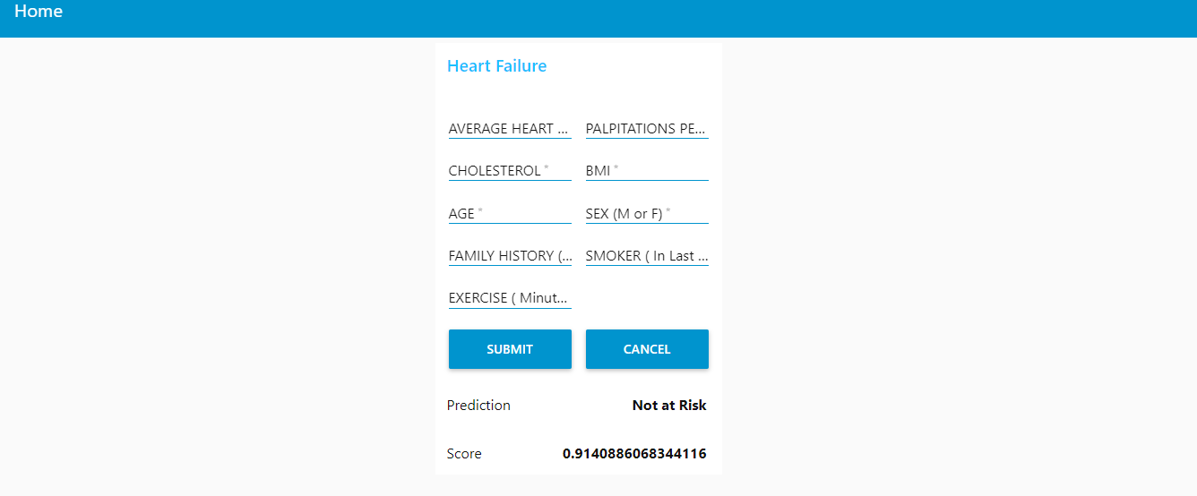

**7.ADVANTAGES AND DISADVANTAGES**

**ADVANTAGES**

This project prevents the people from the avalanche by priory informing them there is a chance of the occurrence of an avalanche or not.

* The earlier prediction is obtained, the much easier we can control it.
* Machine learning can help people make a preliminary judgment about heart failure according to their daily physical examination data, and it can serve as a reference for doctors.
* The advantage of using AutoAI is we don't need to write the code, we just have to give the dataset as input,it automatically builds the model using AutoAI pipeline and gives the model with highest accuracy.

**DISADVANTAGES**

**Deterministic problems:**This method is not very efficient for deterministic problems.

**Lack of good data**: It may lead to problems.Interpretability.

**8.APPLICATIONS**

**.** The application is used to predict diabetes for users.

. This system can serve as a reference for doctors.

**9.CONCLUSION**

Heart failure is a chronic, which can cause many complications. How to exactly predict and diagnose this disease by using machine learning is worth studying.The end product is a web page created and deployed on a node-red app of IBM cloud. Gradient Boosting Classifier is used built in AutoAI with 0.763 accuracy and deployed on watson studio using machine learning service.

The web page has input fields such as AVGHEARTBEATSPERMIN,PALPITATIONSPERDAY,CHOLESTEROL,BMI,AGE,SEX,FAMILYHISTORY,SMOKERLST5YRS,EXERCISEMINPERWEEK and an output field named as Prediction and Score which gives At risk or Not risk and numeric value based on the inputted values.

**10.FUTURE SCOPE**

Heart Failure can be the terminal condition of many cardiovascular diseases, including myocardial infarction (MI), valvular heart disease, and various Cardiomyopathies. There is a need to collect and analyze both subjective and objective patient information in order to fully understand the occurrence of readmission of patients with diabetes.This predicting information might improve the intelligent models to identify patients wheather he/she is at at risk or not risk .

**11.BIBLIOGRAPHY**

<https://www.frontiersin.org/articles/10.3389/fgene.2018.00515/fullt>

**12.APPENDIX**

Node-RED Flow Output

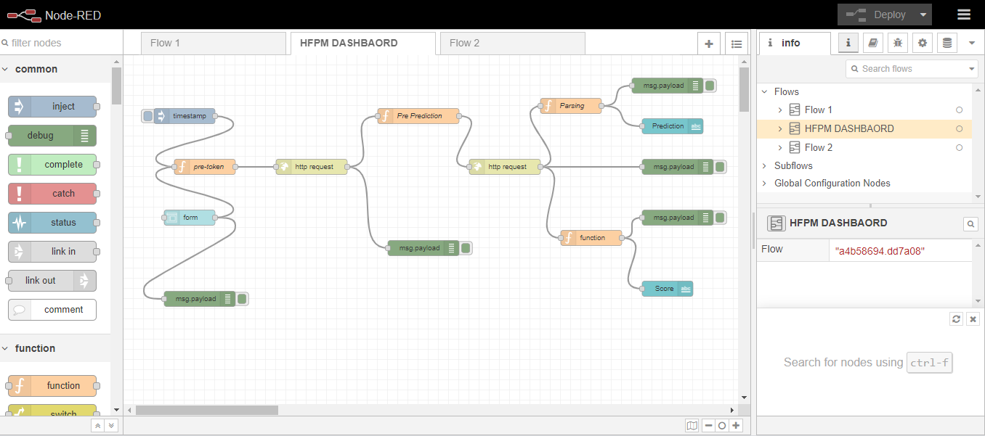

**UI OUTPUT SCREENSHORT**

